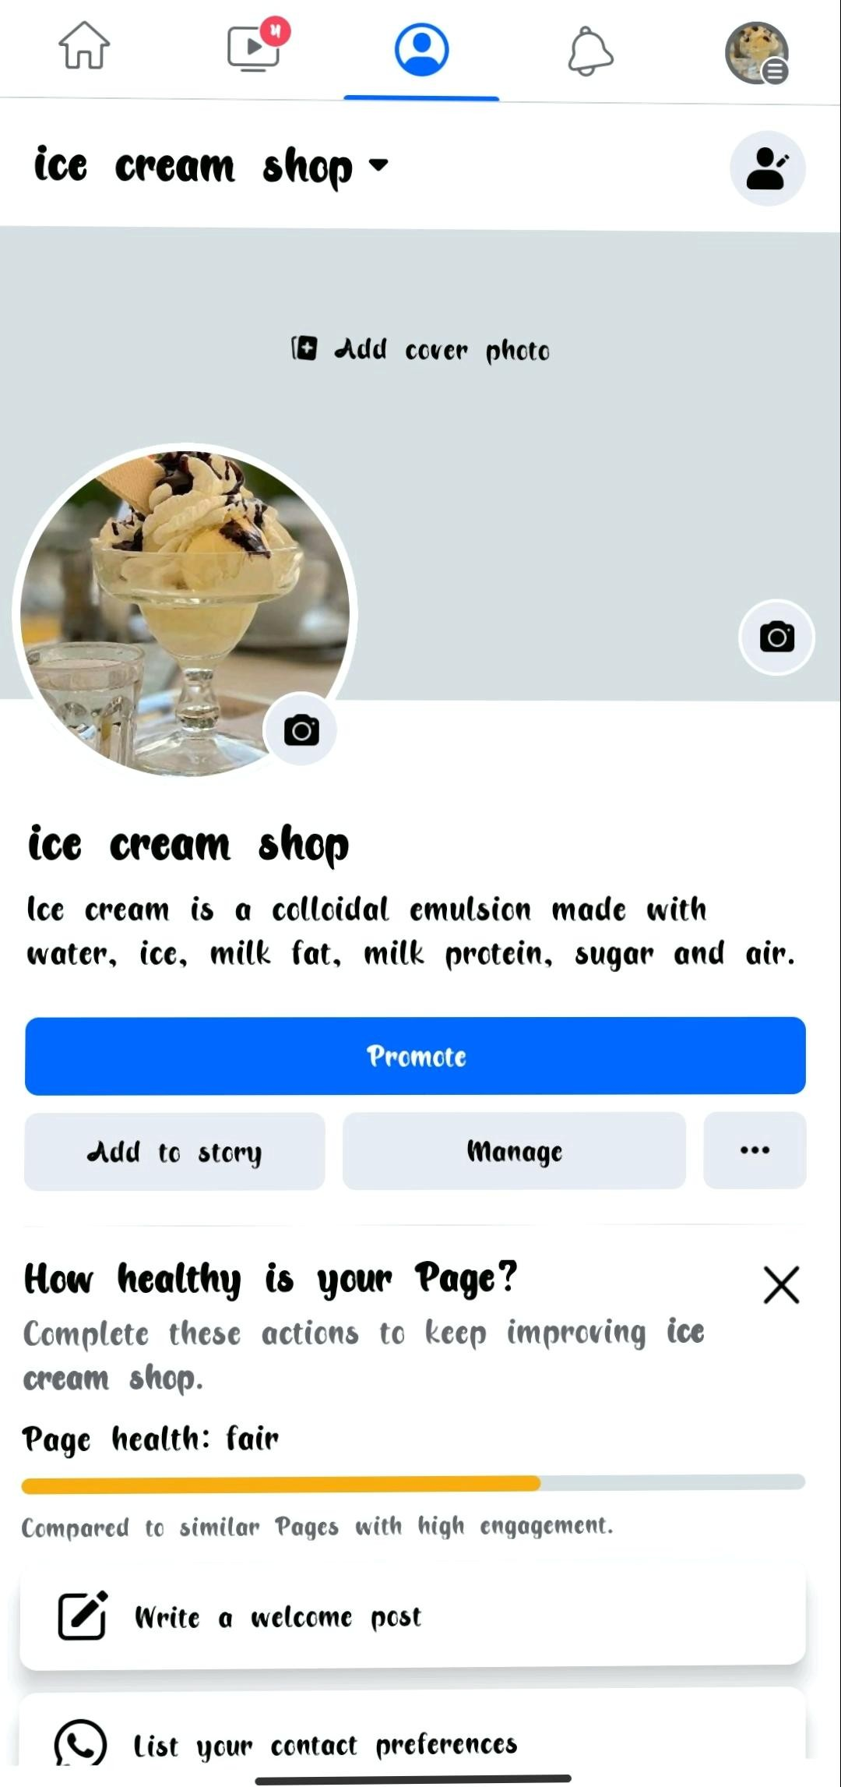

ASSIGNMENT LINK :https://www.facebook.com/profile.php?id=61552079168905&mibextid=ZbWKwL

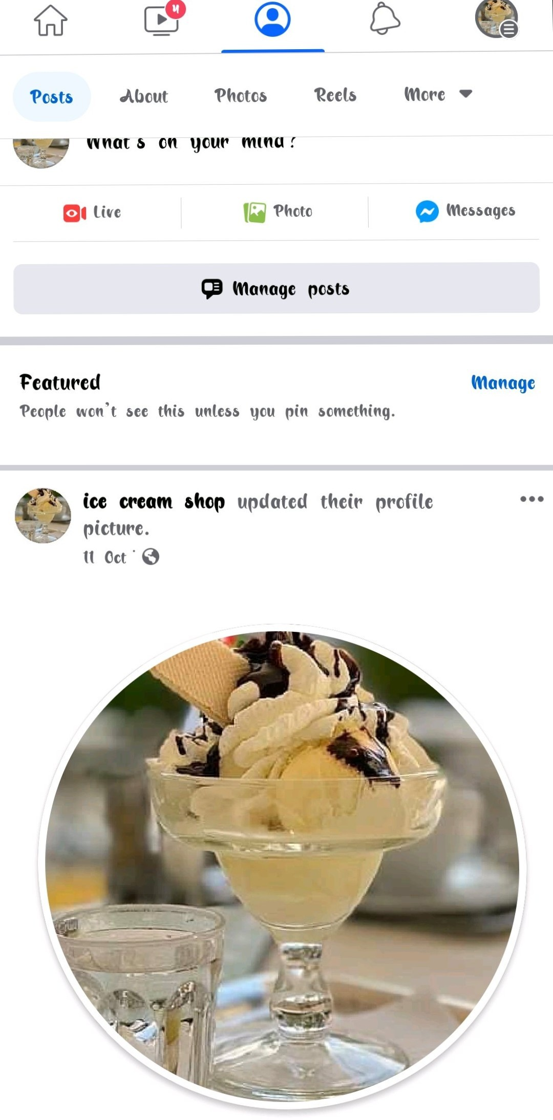[Scanned by Scanner Go](http://scannergo.net/?utm_source=pdf&utm_medium=watermark&utm_campaign=scannergo)

[Scanned by Scanner Go](http://scannergo.net/?utm_source=pdf&utm_medium=watermark&utm_campaign=scannergo)